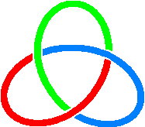  C I C A | SECRETARIAT OF THE CONFERENCE ON INTERACTION  AND CONFIDENCE BUILDING MEASURES IN ASIA  СЕКРЕТАРИАТ СОВЕЩАНИЯ ПО ВЗАИМОДЕЙСТВИЮ  И МЕРАМ ДОВЕРИЯ В АЗИИ

REGISTRATION FORM

Online Seminar on “Maintenance treatment for opiates use disorders”
Monday, 24 October 2022, 11:00-18:30 (Tehran time, UTC+3.30)

Member State:

Prefix (Mr./Mrs./Ms.):
First Name:

Last Name:

Title/Position (incl. organization):

Phone number:

E-mail:

Kindly type in your information and return this registration form
by 22 October 2022
to the following e-mail addresses: s-cica@s-cica.org & a.koshcheev@s-cica.org

